# INTRODUCTION

* 1. Overview

This project is based on zoho books where we maintain the accounts of our company Health Hub Medical clinic. Here we had maintained our expenses and billings

* 1. Purpose

The purpose of the company is to maintain good dealings with the customers and maintain their books and billings correctly

1. **Problem Definition & Design Thinking**
   1. Empathy Map

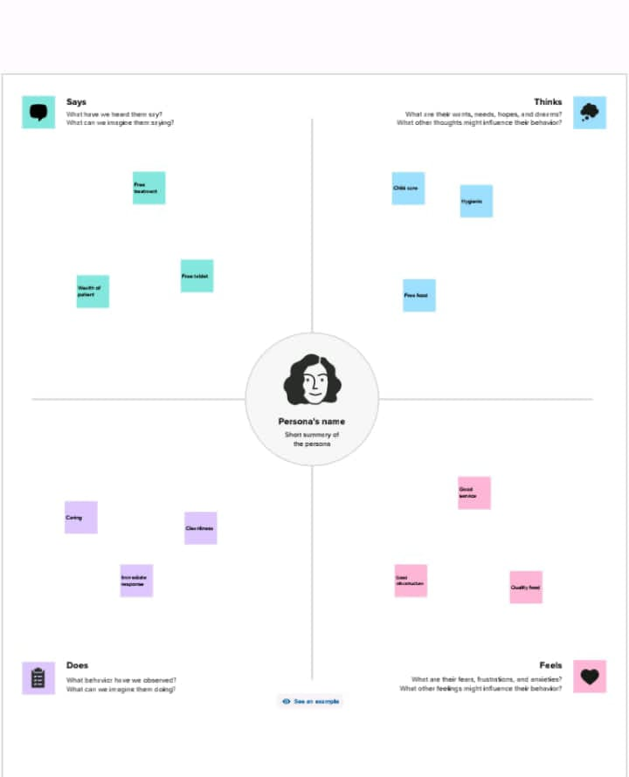

* 1. Ideation & Brainstorming Map

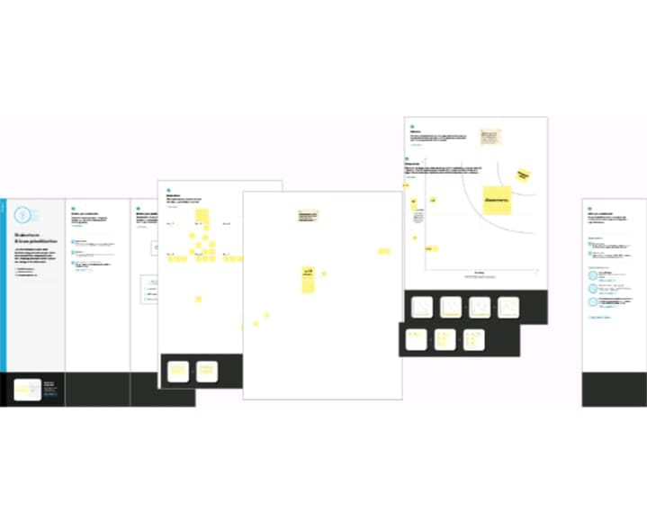

# RESULT

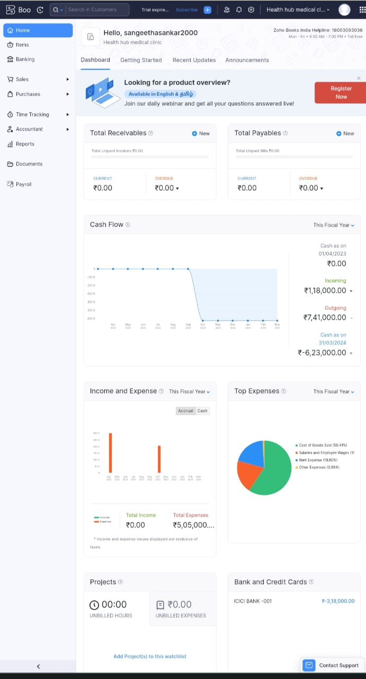

# ADVANTAGES & DISADVANTAGES

Advantages:

* Good relationship with customers
* Quality supply
* Better price system

Disadvantages:

* Risks involved in system
* Lack of manual techniques

# APPLICATIONS

This application is used to maintain the financial accounts of the company and maintains the billing and expenses of the company

# CONCLUSION

So we conclude that we had made this project with the help of zoho books applications and it also helped us to know how to maintain the financial books in zoho books

# FUTURE SCOPE

We make sure to provide better enhancement by having connections with legal companies and provide good services